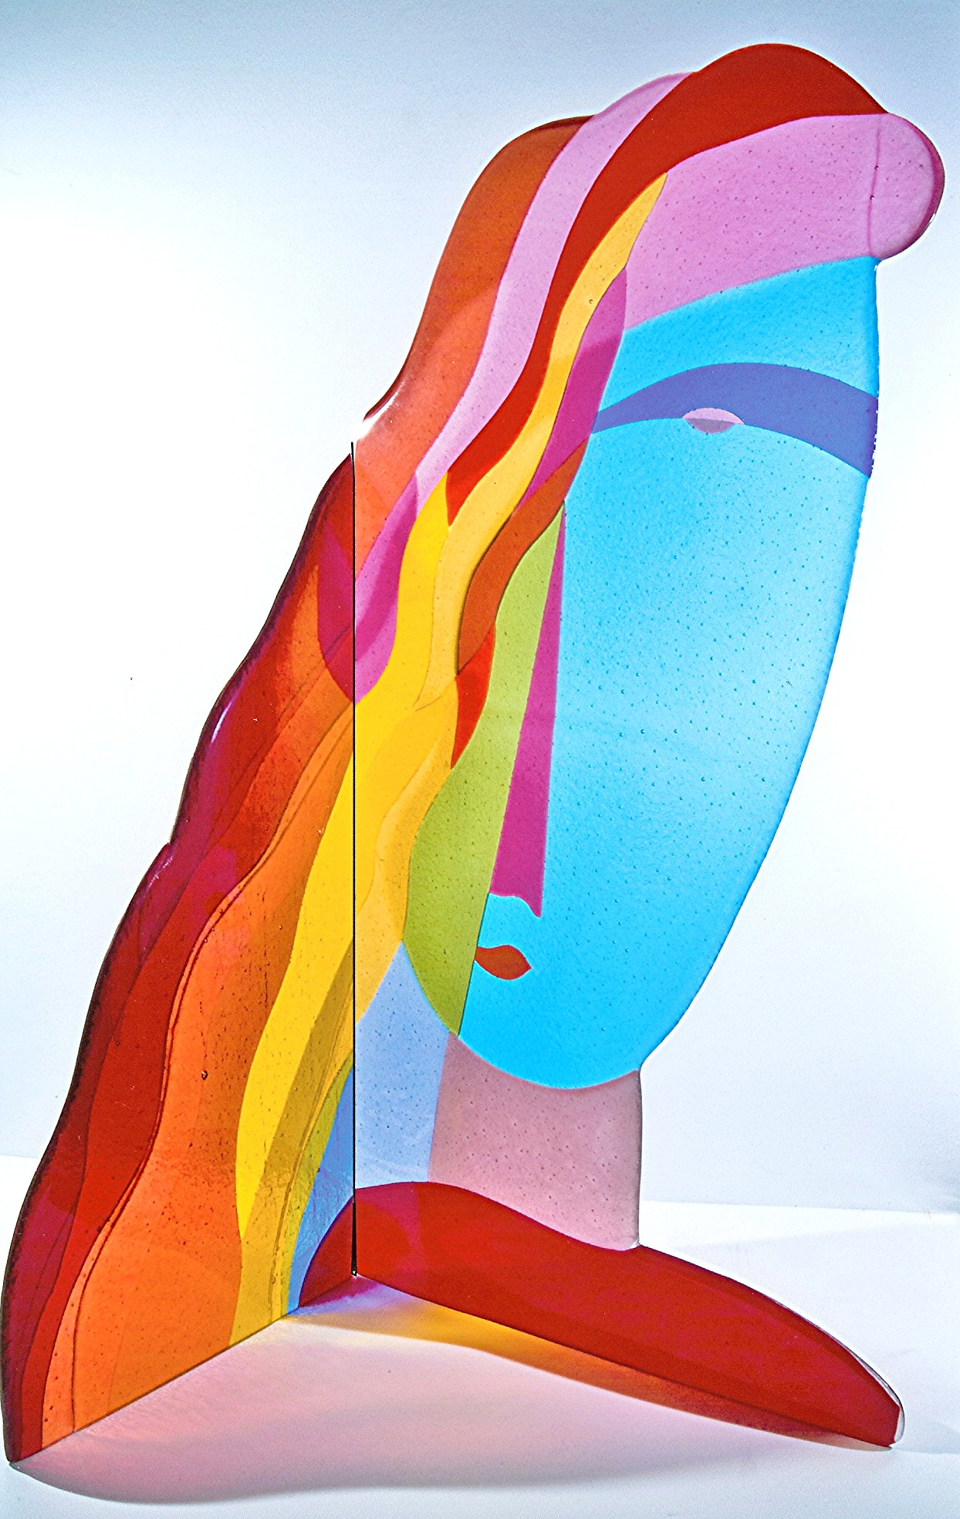**WOMEN & PHILANTHROPY AT THE UNIVERSITY OF TOLEDO**

**GRANT APPLICATION GUIDELINES 2025**

The following are the grant application guidelines for Women & Philanthropy’s current grant-making cycle. Please read and follow them carefully, as incomplete applications will not be

considered.

**Requirements**

1. Applications must be complete, including budget and signature sections.
2. Typed applications are preferred, but hand-printed is acceptable. All must be legible.
3. Submit the application **by February 15, 2025**. Grant requests will be reviewed and awards announced in May.
4. Applications must be submitted to: **Women & Philanthropy at The University of Toledo**

**c/o Allie Berns:** [**allison.berns@utoledo.edu**](mailto:allison.berns@utoledo.edu)

1. Only one application will be considered from any individual, office or department during each grant cycle.
2. Submit only one copy of your application. Keep a copy for your records.
3. Prior approvals from key stakeholders (eg. grounds, legal, facilities, etc.) must be obtained before submitting your application.
4. Any publicity or promotion on a funded project must recognize Women & Philanthropy as a funder.

**Limits of Funding**

1. Funds from Women & Philanthropy will only be used for University of Toledo tangibles that can be identified as funded by Women & Philanthropy***;*** faculty, staff and students may apply.
2. Funds received from Women & Philanthropy are not intended to be used as the sole source of funding on projects or programs of a continuing nature.
3. Projects must be financially feasible. Evidence of any other committed funds must be presented with the application.
4. A reasonable date of completion must be included in the application; *i.e., the completion date must be within 18 months of the grant having been awarded.*
5. A grant request should not exceed the amount Women & Philanthropy has allocated for the grant cycle.

**Women & Philanthropy DOES NOT FUND**

1. Administrative costs for salaried staff, support staff or volunteers.
2. General operating expenses, travel and seminar expenses.
3. Student scholarships, tuition, housing, board or books.
4. Dinner galas, advertising and other special fund-raising projects or events.
5. Projects that are in progress or are completed.

**Additional Information**

The organization is interested in legacy gifts and it is our wish that our gifts be enrichment-based and not consumption-based. Enrichment would be defined as something with longevity and depth and would give tribute to our organization and its members for such a gift. It would be a heritage investment from our members that would serve as an example to younger women in our community. In this way, our gifts will collectively become a primary component of the mentoring process to help build a diverse community of women philanthropists.

Artwork: *A University Woman**by Tom McGlauchlin*

|  |  |
| --- | --- |
| Name of Office, Department or Division |  |
| Contact Person and Title |  |
| Campus Address |  |
| Campus Telephone and Fax Numbers |  |
| Email Address |  |
| Date Submitted |  |



**PROJECT OR PROGRAM INFORMATION**

|  |
| --- |
| Title of your project or program |
| Amount requested from Women & Philanthropy. Note the requirement below to submit a complete budget. |
| Summarize the purpose of the proposed project or program, including the target population. Explain your need for this grant. |
| What are the objectives of the project or program and the expected outcomes? What kind of impact will be realized from receiving this grant? |
| What is your project or program timeline and the time period the grant will cover?    Start date:       Completion date: |
| How is your program or project innovative? |
| How will the impact and outcome of the project or program be measured? |
| Are you receiving funding for this project or program from any other source?  YES  NO |
| If yes, explain (include the amount and source of the other funding) |
| Elaborate on any evidence of collaboration. |
| Have you obtained approval from all key stakeholders to ensure project or program can be executed? |
| Other information you would like the grant committee to know. |
| I understand that *the project must be completed within 18 months from the time the grant is awarded; a dedication event to celebrate the project’s completion will be held, and a written report on the impact of the project will be submitted within a year of the date of the dedication event.*  Signed: |

To complete the grant application process:

Attach a cover letter to this application. This cover letter would usually be prepared and signed by the Dean or the Vice President of your Division and demonstrate approval of your proposal. It should be equivalent to an executive summary of your request.

Attach a complete project or program budget for this grant to include both revenue and expenses (i.e., exactly how you would use the money).

Email the completed application documentation to [allison.berns@utoledo.edu](mailto:allison.berns@utoledo.edu) **no later than February 15, 2025.**